Practical 2
Date - 29/7/25
Game Development:
#include <iostream>
using namespace std;

int main(){
int score[10];
for(int i =0;i<10;i++){
cout<<"Enter Score :";
cin>>score[i];
}
for(int i=0;i<10;i++){
for(int i=0;i<9;i++){
if(score[i]>score[i+1]){
int temp;
temp=score[i];
score[i]=score[i+1];
score[i+1]=temp;
}
}
}
for(int j=0;j<10;j++){
cout<<score[j];
cout<<"\n";
}
return 0;
}

OUTPUT -
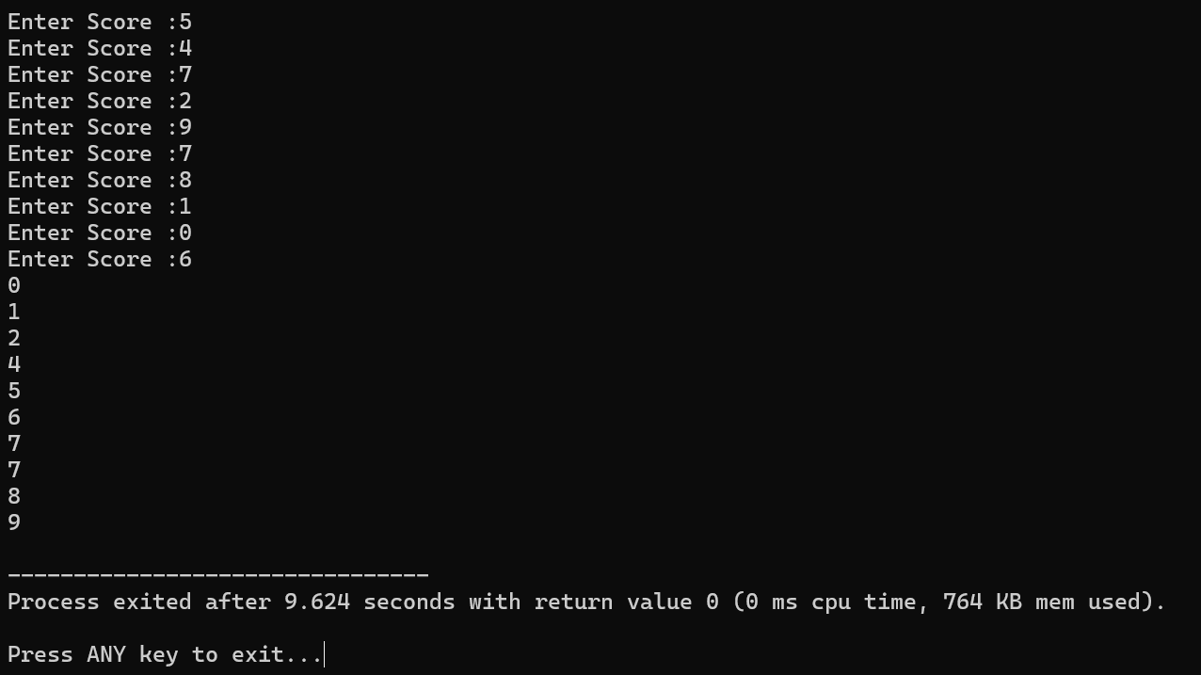

Organizing Cards in a Hand:
#include <iostream>
using namespace std;

void sort(int cards[],int n){
int i,key,j;
for(i=1;i<n;i++){
key=cards[i];
j=i-1;

while(j>=0 && cards[j]>key){
cards[j+1]=cards[j];
j=j-1;
}
cards[j+1]=key;
}
}

void display(int cards[],int n){
cout<<"Sorted order are : "<<endl;
for(int i=0;i<n;i++){
cout<<cards[i]<<endl;
}
}

int main(){
int arr[10] = {9,8,6,5,3,2,7,5,2,11};
int a = sizeof(arr)/sizeof(arr[0]);

sort(arr,a);
display(arr,a);
return 0;
}

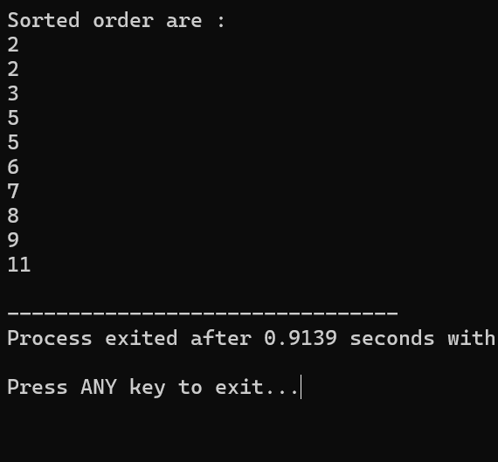
Output -

